**Library Management System - Case Study Documentation For SQL**

**Marks: 20 Timing:4 hours**

**1. Introduction**

This document outlines the SQL queries used to manage and analyze data within a Library Management System (LMS). The system includes functionalities for tracking books, members, and loans. The queries cover various operations, including listing available books, tracking borrowed books, and generating reports.

**2. Database Schema**

**2.1. Create Tables**

* Books Table

CREATE TABLE Books (

BookID INT PRIMARY KEY AUTOINCREMENT,

Title VARCHAR(70) NOT NULL,

Author VARCHAR(70) NOT NULL,

Genre VARCHAR(70),

YearPublished INT,

AvailableCopies INT

);

* Members Table

CREATE TABLE Members (

MemberID INTEGER PRIMARY KEY AUTOINCREMENT,

Name TEXT NOT NULL,

Email TEXT

);

* Loans Table

CREATE TABLE Loans (

LoanID INTEGER PRIMARY KEY AUTOINCREMENT,

BookID INTEGER,

MemberID INTEGER,

BorrowDate DATE,

ReturnDate DATE,

FOREIGN KEY (BookID) REFERENCES Books(BookID),

FOREIGN KEY (MemberID) REFERENCES Members(MemberID)

);

**2.2. Questions**

1. Insert ten records in each table.

2. How can we list the details of books that have only one available copy?

3. How can we find the most popular books based on the number of times borrowed?

4. How to select records from the books table without duplicate records?

5. How can we get the list of members who have borrowed books but haven't returned them ?

6. How can we get the details of books by a specific author?

7. How can we list all the authors with books in the library?

8. How can we get the number of books borrowed by each member?

9. How can we find all the books borrowed by a specific member?

10. How can we list all books available in the library?

**OUTPUT:**

2. **How can we list the details of books that have only one available copy?**



3. **How can we find the most popular books based on the number of times borrowed?**

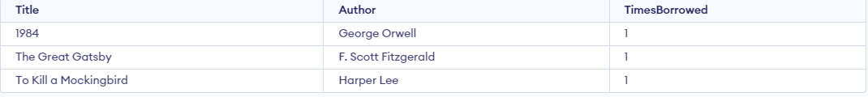

4. **How to select records from the books table without duplicate records?**

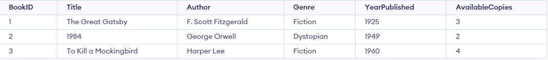

5. **How can we get the list of members who have borrowed books but haven't returned them?**



6. **How can we get the details of books by a specific author?**



7. **How can we list all the authors with books in the library?** 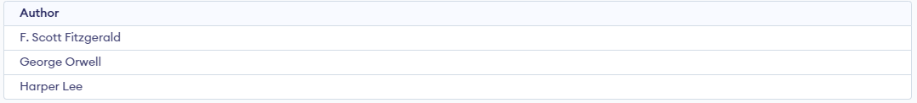

8. **How can we get the number of books borrowed by each member?**



9. **How can we find all the books borrowed by a specific member?**



10. **How can we list all books available in the library**